Committee sessions held today by the HSC; what were the results?
9 Feb 2021
Delegate journalist of New York Times

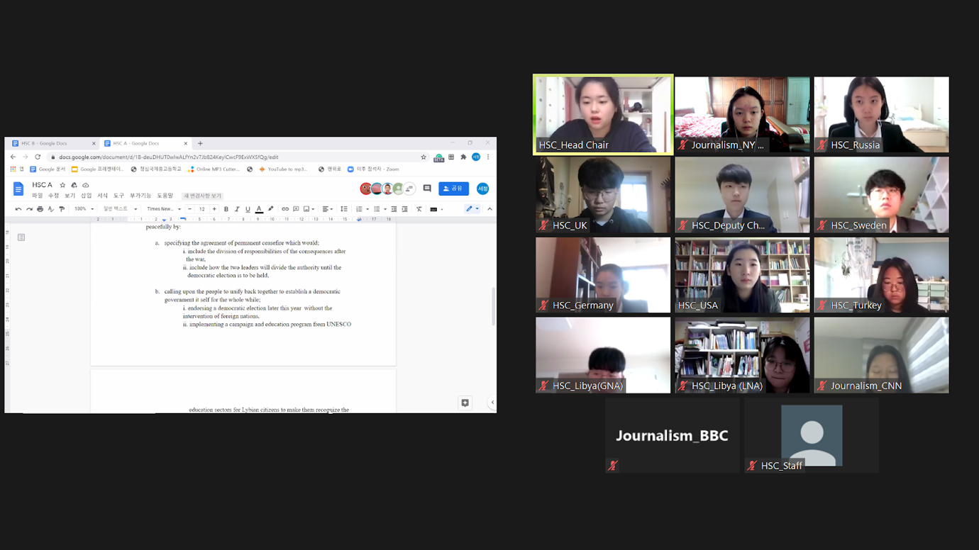
▲Delegates participating in a committee session through Zoom. Photo Yoonbin Cho

Committee sessions were held today by the Historical Security Council (HSC). During the sessions, delegates of the HSC debated the draft resolutions submitted by the two blocs within the committee.

At the end of each committee session, a resolution was passed by the committee-- indicating that all draft resolutions were ultimately accepted.

Interesting amendments were made by delegates, to the draft resolutions. The New York Times will introduce these modifications.

The committee session on the USA’s bloc’s draft resolution
The draft resolution submitted by the delegate of the United States of America (USA)’s bloc originally had operative clauses containing solutions to the destruction caused by the Libyan civil war such as: encouraging the leaders of both sides of the conflict occurring in Libya, taking actions to ameliorate the unstable economy of Libya, and increasing the financial aid for humanitarian purposes for the Libyan people.

Though the content of the resolution (which are mentioned above) did not change, the committee has raised many points concerning the draft resolution submitted by the delegate of the USA. Among them, some led to amendments.

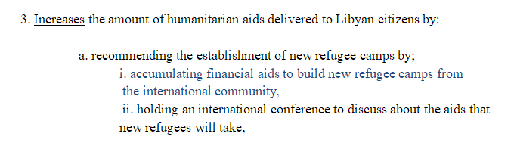
▲The clause of the draft resolution submitted by the delegate of the USA’s bloc.
⇓
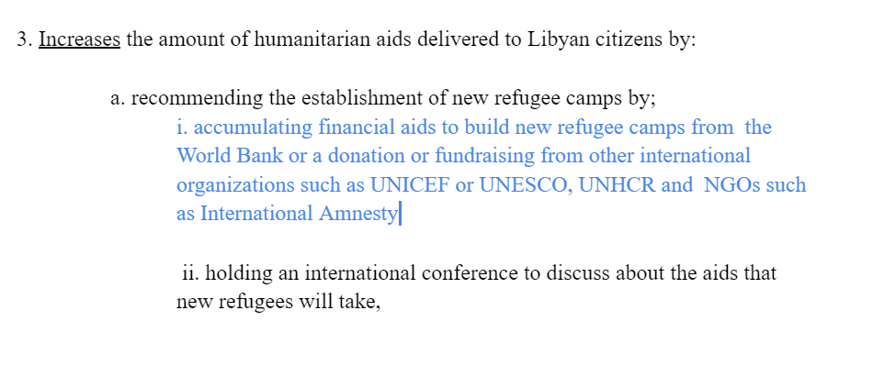

▲The edited version of the clause of the resolution submitted by the delegate of the USA’s bloc.

During the session, the delegate of Zimbabwe introduced an amendment regarding the operative clause 3, sub-clause a, sub-sub-clause i.
He raised speculations of the vagueness the clause contained and suggested the source of the financial aids to be specified.
With further discussion among delegates, the amendment was passed along with a few second-degree-amendments.

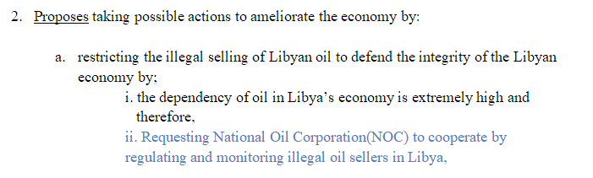
▲The clause of the draft resolution submitted by the delegate of the USA’s bloc.
⇓

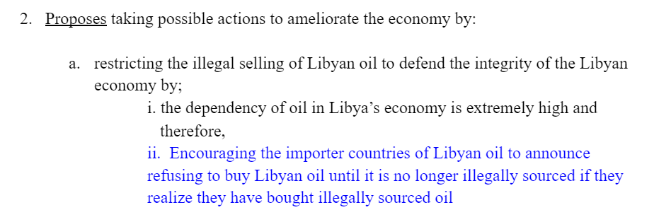
▲The edited version of the clause of the resolution submitted by the delegate of the USA’s bloc.

A call for an amendment for the operative clause 2, sub-clause a, sub-sub-clause ii was made during the session. Suspicions were raised regarding the capability of the National Oil Corporation (NOC) of Libya of restricting the illegal importation of oil effectively.
As a result of the skepticism, the clause in question was modified into one invoking the oil importers to be a part of the effort to restrict the unlawful distribution of oil.

The committee session on Germany’s bloc’s draft resolution
The delegate of Germany and her bloc’s originally submitted resolution included ideas that would: support Libya with solving COVID-19-related health problems, uphold the permanent ceasefire agreement, improve the quality of the lives of Libyan civilians, and protect the refugees of Libya.

The committee session apropos of the draft resolution presented by the delegate of Germany’s bloc contained various fruitful consultations. Consequently, the resolution was reconstructed in particular parts.
Among the edits made, this journal will focus on operative clause 1.

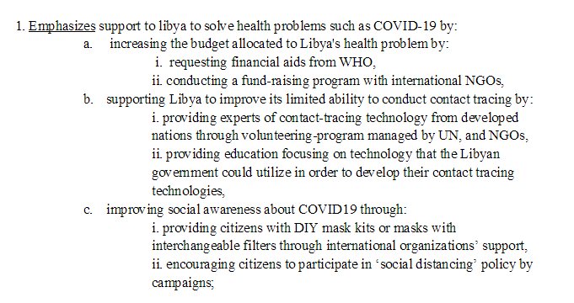
▲The clause of the draft resolution submitted by the delegate of Germany’s bloc.
⇓
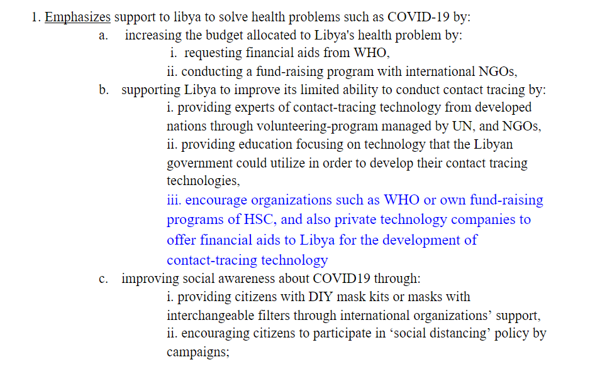
▲The edited version of the clause of the resolution submitted by the delegate of Germany’s bloc.

Operative clause 1 accommodates solutions to the health problems associated with COVID-19.
It initially did not explain how the creation of patient tracking systems would be financially funded.

After the issue was pointed out, the committee added sub-sub-clause iii of sub-clause b of operative clause 1 to enforce the feasibility of the clause as a whole.

Libya’s future
With two resolutions being passed, the sessions have ended for good. But what Libya’s future would look like remains uncertain.
The upcoming elections could be the breaking point for the Libyan people and their democracy. With that in mind, the delegate journalist of the New York Times wishes Libya the best of luck.

